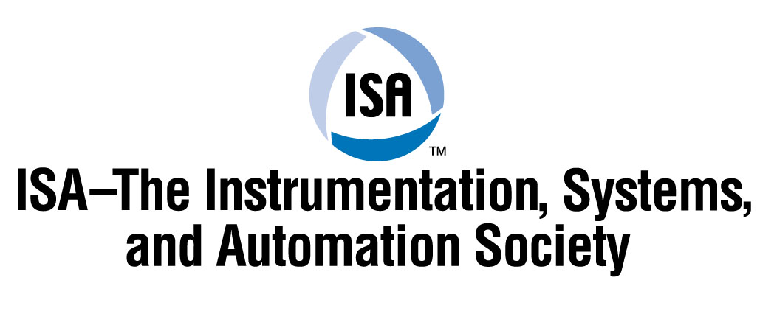

I.S.A IRELAND TECHNICAL TALK

Tuesday 14th OCTOBER 2003 Rochestown park hotel 8.00pm

Techniques for Multi Gas Continuous Emission Monitoring

Speaker: Mr Peter Mc Que of CBISS

In this presentation Peter will cover the following areas:
- Different techniques for analysing emission gases in vents and stacks.
- Single analyser solutions FID chemiluminescence infra red & sampling components.
- Cross stack in-situ .
- In stack infra-red.
- Hot/wet extractive systems.
- Dry extractive systems.
- Calibration issues.
- CEMS software.
- New developments,ie: remote contact software-web based reporting.

This topic will be of particular interest to process, control and Instrument Engineers, Facility Managers and Technicians and Engineers, Production and Maintenance personnel or anyone interested in measurement and control.

This presentation is made as a service to our members and people with an interest in Industrial Instrumentation Automation and control. No prior booking required. We look forward to seeing you there. Please feel free to invite a colleague!

If you have any queries please contact Trevor Edwards (021) 4379262
or email on gsk@cgservices.ie

